0.6: New note in Single page app diagram

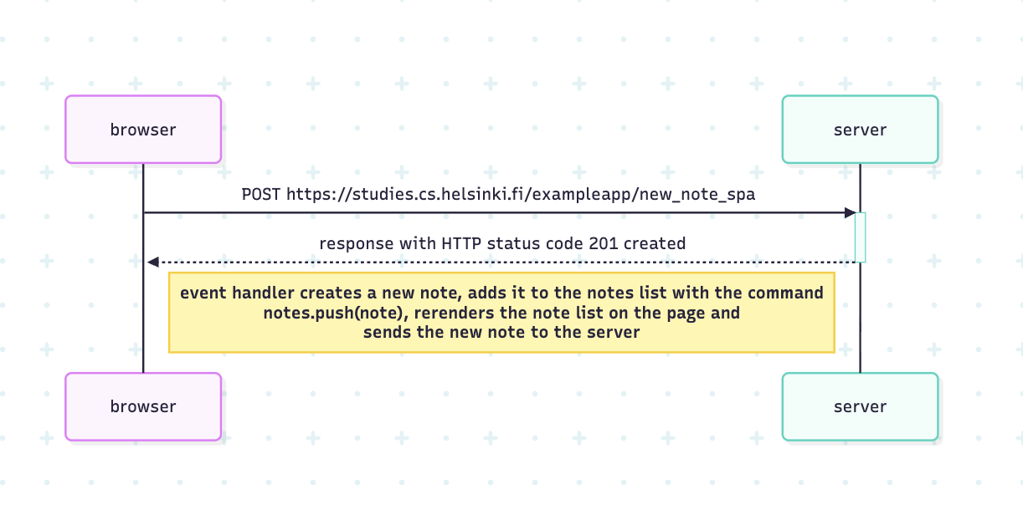

sequenceDiagram
participant browser
participant server
browser->>server: POST https://studies.cs.helsinki.fi/exampleapp/new_note_spa
activate server
server-->>browser: response with HTTP status code 201 created
deactivate server

Note right of browser: event handler creates a new note, adds it to the notes list with the command <br> notes.push(note), rerenders the note list on the page and <br>sends the new note to the server

